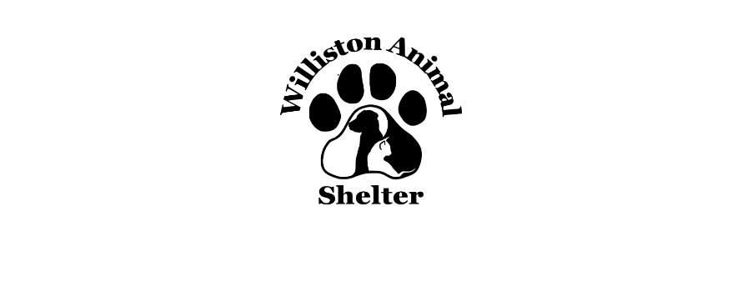
Name of Animal: Dog/Cat Date:

In order to be considered as an adopter you must:
- Be 21 years of age or older.
- Have identification showing your present address. Have the knowledge and consent of your landlord.
- The pet you have chosen must fit within any weight and requirements your landlord or community may have, including breed restrictions. (Remember, puppies get bigger!)
- If you already own animals, they must be up to date on their core vaccines, including but not limited to rabies and other current preventions.
- Be able and willing to provide a loving, safe and peaceful environment for this pet. Be financially stable and willing to provide any necessary medical care.
- You cannot currently be in violation of the animal control ordinance, and you cannot have had any serious animal control ordinance violations in the past.
Required Vaccines:
- Rabies (Must be administered by a licensed veterinarian)
- DAPP/DAPP2/DHPP
- Bordetella
- <6 Months must have Parvo Testing
- >6 Months must have heartworm testing or 6 months of preventative.

Pet ownership is a serious responsibility. The policy of this adoption group is to ensure that each person who adopts a pet is aware of the responsibility and is capable and willing to accept that responsibility morally, physically, and financially.

The following questionnaire has been designed to aid both you and the adoption group in deciding if you and/or your family are adequately prepared to assume the responsibility of pet ownership and to help place pets in a proper home. Please be sure to ANSWER ALL QUESTIONS and feel free to add your own comments. If a question does not apply write N/A.

Thank you for your interest in adopting a pet!

Owner Information

Name:

Phone:

Email:
Address: City/State: Zip:
Occupation:

Please list the name, age and relationship to yourself of each person currently living in your house:

Does anyone living in your home have any known allergies? Yes No
Your type of dwelling: House Condo Apartment Townhouse
Length of time at residence:
Do you plan to move within the next 6-12 months? Yes No
If you rent, are pets allowed? Yes No Pet Deposit? Yes No
What is the name of the property owner?
Contact name and phone number:
Why do you want to adopt at this time?
Do all adults in your household know you plan to adopt? Yes No
Have your children ever been around dogs and/or cats? Yes No
Do your current pets get along with other animals? Yes No
This pet will be: Indoor only Mostly Indoor Mostly Outdoor Outdoor only
Do you have a fenced yard? Yes NoType? Wood Chain Link Split Rail Height
Where do your pets stay if and when you travel?

Past Pet Information

Please list the name, type, age, gender, and if pet is spayed or neutered of all current animals. (i.e.- Duke, yellow lab, 1 ½ years old, male neutered)
- Are your companion animals spayed/ neutered? Yes No
- If not, why?
- Are your animals current on all vaccinations? Yes No
- Date of last vaccinations: If adopting a CAT, do you plan to declaw? Yes No
- Name and Phone Number of current or last veterinarian
- How did you hear about Williston Community Animal Rescue?

Is there anything else you would like to tell us that you think would be important when considering your application?

Please read and sign below: Many factors determine which applicant will be matched with a particular pet. If you are not able to adopt a pet today, it does not mean that you are not considered a good pet owner or that your home is not acceptable. Our goal is to place all animals into homes that will best suit their individual needs. Please ask for clarification if you have any questions.

I have completed this application truthfully and fully understand the adoption process.

Signature: Date:

If we do not call or email you within 7 days of receiving your application, it means that either, the pet was adopted by a previous applicant or we felt the situation presented on the application was not the right situation for that particular pet.

