CITY OF WILLISTON

BOARD OF ADJUSTMENT AND CODE ENFORCEMENT

AGENDA

DATE: September 27, 2021
TIME: 6:00 PM

PLACE: City Council Chambers

Board Members | Staff
Sharon Brannan, Chair | Wayne Carson, Code Enforcement Officer
David Ragland, Vice Chair | Allison Folds, City Attorney
Lisa Clark | Krystal Ramos, Secretary of the Board
Colette Roth
Vacant
Paul Missall
Pam Myhree

Call To Order

Pledge

- Roll Call

- General Welcome Notice by Chairwoman

- Approval of Agenda

- Approval of Minutes – September 23, 2021 (See Agenda Item 1)

- Remarks of Staff or Attorney

- Remarks of Chairwoman

- City Staff Sworn by Secretary

- NEW CASES

  - CV21-07 A+ Homes

Property Owner: A+ Homes DBA Armstrong Homes
Property Address: 420 NW 7th Street
Non Compliance Notice from City: August 5, 2021
Deadline for Compliance: September 4, 2021

An inspection by City Staff of the above listed parcel shows the property to have code deficiencies. Specifically, Section 48-2, City of Williston Code of Ordinances, which states that: “It shall be unlawful for any owner of real property within the city to create, keep, maintain, or allow the existence of any unsafe building or hazardous land, as defined in this chapter, in or on such property”. A notice was mailed on August 5, 2021 (See Agenda Item 2).

The notice that was mailed to the Property Owner on August 5, 2021 required a response or for the property to be brought into compliance by September 4, 2021. No response has been received by City Staff from the Property Owner regarding their intentions for bringing the property into compliance, and it is still non-compliant. City Staff has noted that the roll-off dumpster that has been on the property has been relocated from one side of the property to another, but no other changes have been identified.

Staff recommends the following:

In BACE Case CV21-07, I (State Name) move to find the Respondent (and/or additional responsible party) guilty of the violation(s) as set forth in the Notice of Violation and give the Respondent (and/or additional responsible party) ___ days to come into compliance by taking correction action.

  - CV21-12 Indellicati

Property Owner: William Indellicati
Property Address: 105 SE 4th Street
Non Compliance Notice from City: August 27, 2021
Deadline for Compliance: September 13, 2021

An inspection by City Staff of the above listed parcel shows the property to have code deficiencies. Specifically, Section 48-2, City of Williston Code of Ordinances, which states that: “It shall be unlawful for any owner of real property within the city to create, keep, maintain, or allow the existence of any unsafe building or hazardous land, as defined in this chapter, in or on such property”. A notice was mailed on August 27, 2021 (See Agenda Item 3).

No response has been received by City Staff from the Property Owner regarding their intentions for bringing the above listed property into compliance. A re-inspection performed by the Code Enforcement Officer shows no change to the property.

Staff recommends the following:

In BACE Case CV21-12, I (State Name) move to find the Respondent (and/or additional responsible party) guilty of the violation(s) as set forth in the Notice of Violation and give the Respondent (and/or additional responsible party) ___ days to come into compliance by taking correction action.

- REPEAT OFFENDERS

CV21-13 Vamosi

Property Owner: Pamela Vamosi
Property Address: 315 SE 5th Street
Non-Compliance Notice from City: August 24, 2021
Deadline for Compliance: September 8, 2021

An inspection by City Staff of the above listed parcel shows the property to have code deficiencies. Specifically, Section 48-2, City of Williston Code of Ordinances, which states that: “It shall be unlawful for any owner of real property within the city to create, keep, maintain, or allow the existence of any unsafe building or hazardous land, as defined in this chapter, in or on such property”. A notice was mailed on August 24, 2021 (See Agenda Item 4).

The Property Owner has been actively working on bringing the property into compliance and has boarded the windows to ensure no access to the unsafe structure, however the property is still not fully compliant. A re-inspection performed by the Code Enforcement Officer shows that the Property Owners are working to bring the property into compliance.

Staff recommends the following:

In BACE Case CV21-10, I (State Name) move to find the Respondent (and/or additional responsible party) guilty of the violation(s) as set forth in the Notice of Violation and give the Respondent (and/or additional responsible party) ___ days to come into compliance by taking correction action.

  - CV21-13 CSX Transportation

Property Owner: CSX Transportation
Property Address: 715 E. Noble Avenue
Non Compliance Notice from City: August 30, 2021
Deadline for Compliance: September 13, 2021

An inspection by City Staff of the above listed parcel shows the property to have code deficiencies. Specifically, Section 48-2, City of Williston Code of Ordinances, which states that: “It shall be unlawful for any owner of real property within the city to create, keep, maintain, or allow the existence of any unsafe building or hazardous land, as defined in this chapter, in or on such property”. A notice was mailed on August 30, 2021 (See Agenda Item 5).

The Property Owner responded to City Staff and stated their intentions for bringing the above listed property into compliance by the deadline of September 13, 2021. A re-inspection performed by the Code Enforcement Officer shows some change to the property, however it is still not fully compliant.

Staff recommends the following:

In BACE Case CV21-13, I (State Name) move to find the Respondent (and/or additional responsible party) guilty of the violation(s) as set forth in the Notice of Violation and give the Respondent (and/or additional responsible party) ___ days to come into compliance by taking correction action.

- Cases Read For Closure By Secretary - None

- Reduction Hearings - None

- Old Business

  - Case Updates

i. CV21-04 arc café usa (Hardee’s)

Property Owner: Arc Café USA, Mark Robinson (Manager)
Property Address: 306 W. Noble Avenue

Code Enforcement Officer noted that property owned by Arc Café USA, referred to as the Hardee’s, located at 306 W. Noble Avenue was in violation of the City of Williston Code. To date, the property is still non-compliant regarding the buffer.

i. CV21-05 Nature Coast Hospital (Former)

Property Owner: Complete Business Solutions Group, Inc.
Property Address: 125 SW 7th Street

Code Enforcement Officer noted that property owned by Complete Business Solutions Group, Inc., referred to as the former Nature Coast Hospital, located at 125 SW 7th Street was in violation of the City of Williston Code. To date, the property is still non-compliant regarding the overgrowth of vegetation.

- New Business - None

- Announcements
- Adjourn

NEXT MEETING – october 25, 2021

AGENDA ITEM 1: AUGUST 23, 2021 MINUTES

CITY OF WILLISTON
BOARD OF ADJUSTMENT AND CODE ENFORCEMENT BOARD
MINUTES

DATE: August 23, 2021
TIME: 6:00 PM

PLACE: City Council Chambers

BOARD OF ADJUSTMENT AND CODE ENFORCEMENT COMMITTEE MEMBERS

Sharon Brannan, Chair | Staff
David Ragland, Vice Chair | Laura Jones, City Planner
Colette Roth | Wayne Carson, Code Enforcement Officer
Lisa Clark | Allison Folds, City Attorney
Paul Missall | Kryssy Ramos, Secretary of the Board
Pam Myhree
Vacant

CODE ENFORCEMENT

- Call To Order- 6:00 PM

- Pledge of Allegiance

- Roll Call – All Present

- General Welcome Notice By Chairwoman

- Approval of Agenda – Ms. Kryssy Ramos states that there is an addition to the agenda and explains the additions. Mr. David Ragland motioned to approve agenda. Ms. Pam Myhree seconded motion. Motion carried 6-0.

- Approval of Minutes ––Mrs. Pam Myrhee motioned to approve June 28th, 2021 minutes. Mr. David Ragland seconded motion. Motion carried 6-0.

- Remarks of Staff or Attorney

Mr. Allison Folds, City Attorney, addresses the Board, thanks them for allowing him and his practice to serve as counsel for the City, and welcomes all to contact the office with any questions that they may have. Mrs. Sharon Brannan thanks him for his attendance and for his introduction.

Ms. Kryssy Ramos states on behalf of the staff that a request has come from City Council that a representative of BACE be present at the second City Council meeting of each month, particularly the Chair or Vice Chair, regardless of whether or not there is business to address. Mrs. Brannan requests that BACE be prioritized at the top of the City Council agenda, to which Mrs. Jones replies that she will ensure that BACE is prioritized at the beginning of the agenda as they were in the past. Mrs. Brannan asks if a staff member can send out reminders to the Chair and Vice Chair’s city and personal emails, to which Mrs. Laura Jones replied, “we can do both.”

Mrs. Brannan asks whether BACE members can receive reminders and agendas to their personal email addresses or not, to which Mrs. Laura Jones replies that it would require too much manpower and storage space in the event of a public records request; as it would require that the City’s IT Manager be responsible for pulling all personal email records for the BACE members and storing them as well. The City’s server is not set up to accommodate that much storage space. Mrs. Brannan asks if it would be alright if someone could send out an email to the Board member’s personal email addresses to alert them to check their City email addresses. Mrs. Jones replies that she is unsure as to whether that would be possible, but that it should be, then asks Mr. Folds to speak to that. Mr. Folds states that even that could open the potential for pulling personal emails. Mrs. Brannan states that, had she not gotten a phone call from Ms. Ramos, Secretary of the Board (BACE), she would not have known to check her email for the agenda that she had received in her City email. Mrs. Brannan asks Mrs. Colette Roth if she ever even checks her email, to which Mrs. Roth replies that her email is not working properly and she has to get it fixed. Ms. Ramos states that a member of City staff would be more than happy to drop off agendas to their respective homes or business places to accommodate the inconvenience of not being able to email the Board members on their personal emails. Ms. Ramos also states that the agendas are printed a week in advance and are available to pick up at the Board’s leisure as well. Mr. Paul Missal states that Wayne (Carson) used to drop the agendas off, and Ms. Ramos agrees that he still can at the Board member’s request. Mr. Wayne Carson says he is out every day and he can do that. Mrs. Brannan asks that we please call to let the Board members know to check their emails, as well as to remind them of upcoming meetings.

- Remarks Of Chairwoman – None

- City Staff Sworn By Secretary
Swore in City Planner, Ms. Laura Jones, Code Enforcement Officer Mr. Wayne Carson.

- New Cases:

  - CV21-04 Hardee’s (Arc Café USA, DBA Phase Three Brands)

Ms. Ramos informed the Board that no response has been received from Hardee’s legal representative or manager regarding the requirements of reinstalling and maintaining the landscaped buffer. Mrs. Brannan asks what the name of the company is on the Levy County Property Appraiser’s website, Ms. Ramos states the name on the Property Appraiser’s website, and Mrs. Brannan asks that it be referred to by that name. Mr. Folds agrees that the case must be referred to by the name on the Property Appraiser website. Mrs. Brannan asks for clarification that the new case only specifically sites the buffer, to which Ms. Ramos agrees, and Mrs. Brannan restates the case. Mrs. Brannan asks for a member of the Board to read the recommendation. Mrs. Lisa Clark read the recommendation and the Board discusses how they would like to proceed. Mrs. Clark makes a motion to give the respondent 10 days to comply, and Mrs. Pam Myrhee seconds the motion.

Mr. Jobe Penney (Resident) is sworn in and says everything was supposedly compliant, but nothing has been done and states that he has pictures of the fence down as well as other things. Mr. Penney states that the bushes were trimmed, and the debris was thrown into his yard. Mr. Penney proceeds to show the Board pictures from his phone of the non-compliance issues that he is citing. Mr. Carson speaks regarding the fence issue as well as the trash and says that is no longer an issue and not to be addressed today. Mr. Penney states that he believes the fence is not in compliance. Mrs. Brannan asks Ms. Ramos to bring the Board up to speed on the issues that were addressed with Hardee’s in the last meeting since Mr. Folds is new to the case, and Ms. Ramos summarizes the previous (closed) case, CV20-11. Ms. Ramos states that the last case’s issues were remediated and that the property was brought into compliance, so the case is closed but the company still owes $250 in administrative fines. Mr. Penney disagrees, stating that the property never was compliant and that the buffer should have been a part of the previous case. Mr. Penney states that the fence and trash were never compliant, and Mrs. Brannan asks if the trash is a continuing issue. Mrs. Brannan asks Mr. Carson to go by Hardee’s property on August 24, 2021 to verify that the fence is down. More discussion pertaining to the trash and the fencing being down occurs, and it is decided that Mr. Carson will check the property again. Pertaining to the buffer, the motion carries 5-0.

In BACE Case CV21-04, I Lisa Clark move to find the Respondent (and/or additional responsible party) guilty of the violation(s) as set forth in the Notice of Violation and give the Respondent (and/or additional responsible party)10 days to come into compliance by taking corrective action.

Mrs. Pam Myrhee seconds the motion. Motion carries 6-0. Mrs. Brannan states that the trash issue and fence issue can be tabled until the next meeting.

B. CV21-05 NATURE COAST HOSPITAL (FORMER)

Ms. Ramos read the violation letter for the Board and states that no reply has been received by the Respondent. Ms. Ramos also informs the Board that the former hospital will be up for tax sale in the coming month, and it is not expected that the property will be brought into compliance. Mrs. Brannan stated that it is best practice to cite the issues with the hospital in case the hospital tax sale is delayed, postponed, or does not happen. Mrs. Brannan stated that any property in city limits are required to be maintained, and recommends that we follow through with citing them for non-compliance. More discussion about how long the Board should give the hospital for compliance, and then Mrs. Brannan asks if the Board is ready to make a recommendation, and Mrs. Myrhee read the recommendation to make the motion.

In BACE Case CV21-05, I Pam Myrhee move to find the Respondent (and/or additional responsible party) guilty of the violation(s) as set forth in the Notice of Violation and give the Respondent (and/or additional responsible party) _10_ days to come into compliance by taking correction action.

Mrs. Colette Roth seconded the motion. Motion carries 6-0.

C. CV21-06 LION’S CLUB (REPEAT OFFENDER)

Ms. Ramos read the violation letter for the Board and states that the property has been brought into compliance as of Friday August 20, 2021. Mrs. Brannan says that this is a statement to the Lion’s Club, and that it should not have to get to the point of a Code Enforcement violation before their lawn is mowed. Nothing is recommended and the Chair moved to the next agenda item.

- Cases Read For Closure – None
- Reduction Hearing – None

- Old Business

D. CV21-02 Antique store

Ms. Ramos stated that this is just a case status review, and that the Antique Store is still non-compliant. Ms. Ramos continues that the daily fine of $100 has still not been paid, and the total due as of the agenda date is $4,700, and the meeting date of August 23, 2021 adds 10 days to the fine, which would now make it a total of $5,700 due. Ms. Ramos tells the Board that the next step is for the City Attorney to file an official Order to Correct.

- New Business

Mrs. Brannan reminded the Board know that there is still a vacancy on the BACE Board in case anybody knows anybody who is interested.

BOARD OF ADJUSTMENTS

- No New Business

- Announcements - None

- Adjourn – Mrs. Roth moves to adjourn, and Mrs. Pam Myhree seconded the motion. Motion carries 6-0. Mrs. Brannan adjourned at 6:30 PM.

NEXT MEETING – September 27, 2021

_____________________________ ______________________________
SHARON Brannan, Chairperson KRYSSY RAMOS, Secretary

Minutes of the BACE meeting may be obtained from the City Clerk. The minutes are recorded, but not transcribed verbatim. Persons requiring a verbatim transcript may make arrangements with the City Clerk to duplicate the recordings or arrange to have a court reporter present at the meeting. The cost of duplication and/or court reporter will be borne by the requesting party.
In accordance with Section 286.26, Florida Statutes, persons with disabilities needing special accommodations to participate in this meeting should contact the City Clerk’s office no later than 5:00 P.M. on the day prior to the meeting.
AGENDA ITEM 2: CV21-07 - A+ Homes DBA Armstrong Homes, 420 NW 7th Street
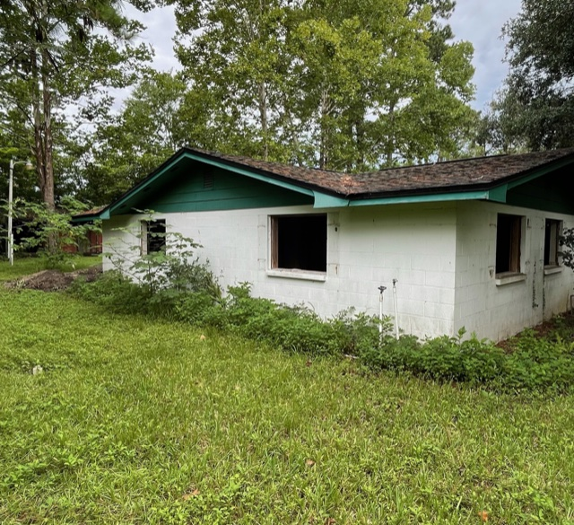

AGENDA ITEM 2: CV21-07 - A+ Homes DBA Armstrong Homes, 420 NW 7th Street

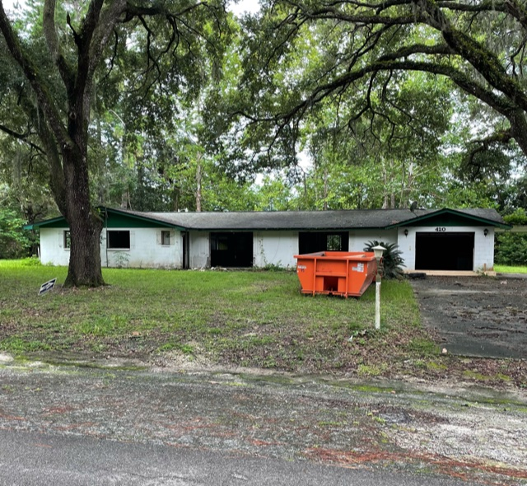

AGENDA ITEM 2: CV21-07 - A+ Homes DBA Armstrong Homes, 420 NW 7th Street

AGENDA ITEM 2: CV21-07 - A+ Homes DBA Armstrong Homes, 420 NW 7th Street

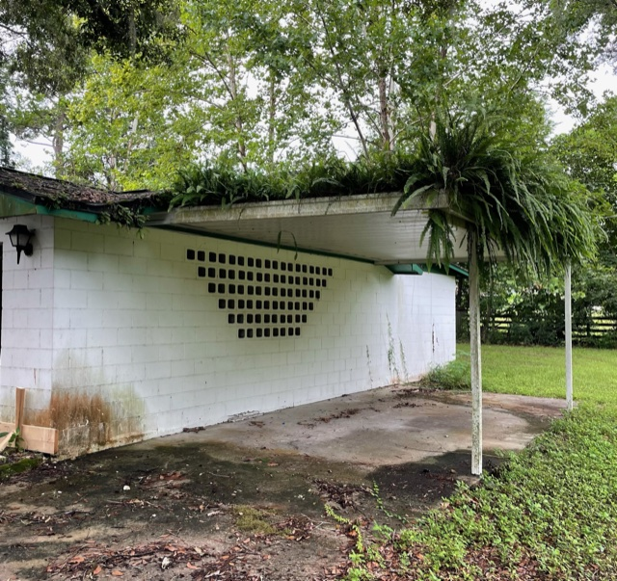

AGENDA ITEM 2: CV21-07 - A+ Homes DBA Armstrong Homes, 420 NW 7th Street

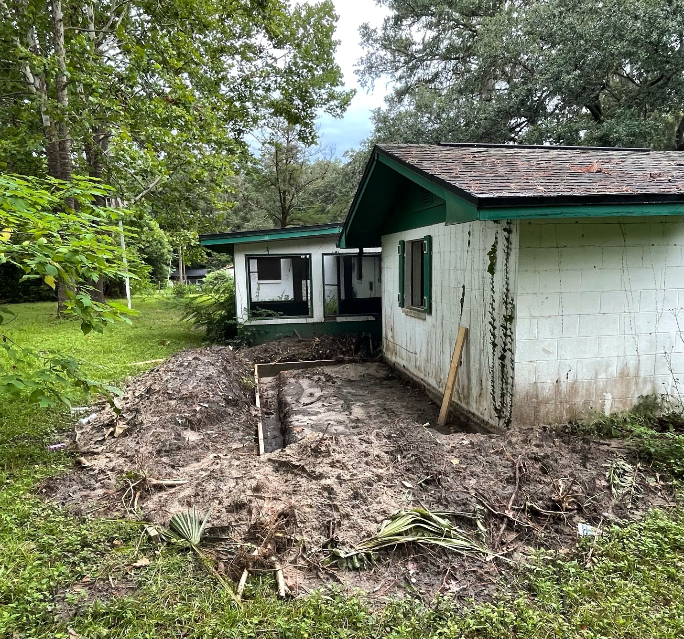

AGENDA ITEM 3: CV21-12 William Indellicati, 105 SE 4th Street

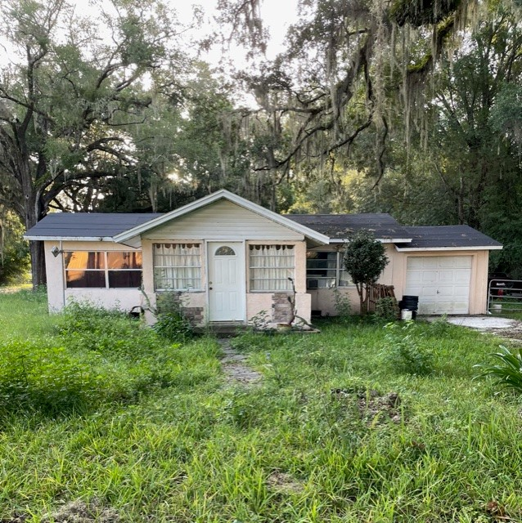

AGENDA ITEM 3: CV21-12 William Indellicati, 105 SE 4th Street
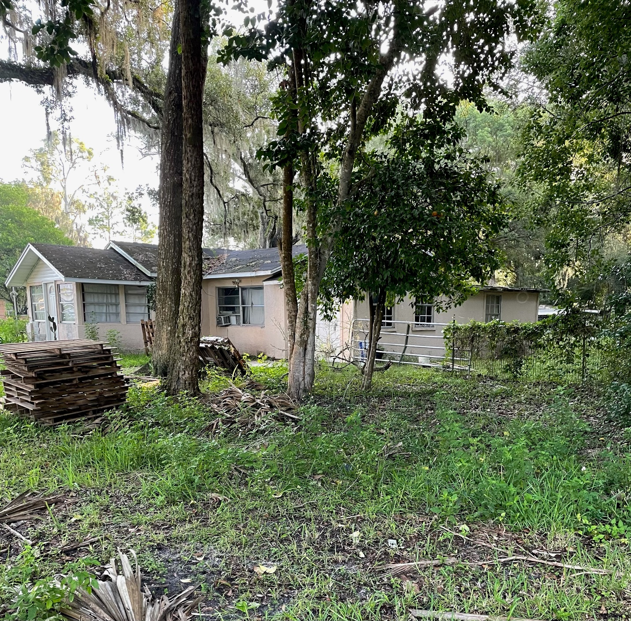

AGENDA ITEM 3: CV21-12 William Indellicati, 105 SE 4th Street
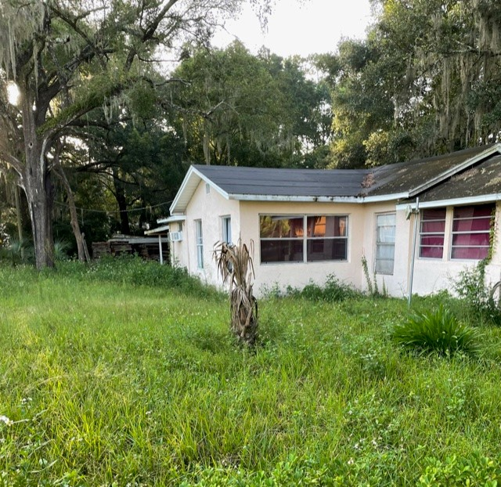

AGENDA ITEM 3: CV21-12 William Indellicati, 105 SE 4th Street
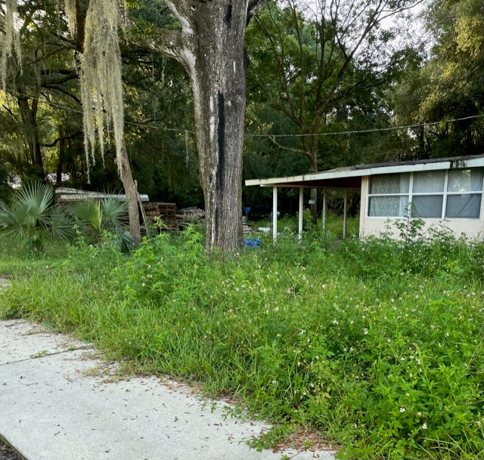

AGENDA ITEM 3: CV21-12 William Indellicati, 105 SE 4th Street
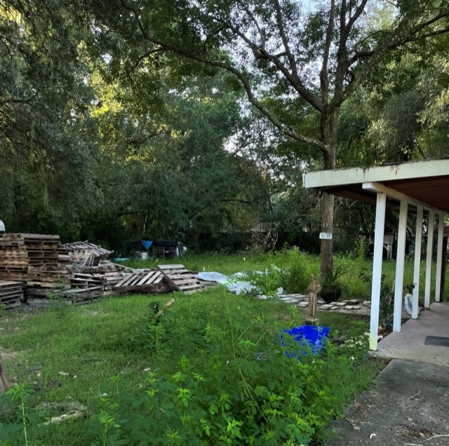

AGENDA ITEM 3: CV21-12 William Indellicati, 105 SE 4th Street
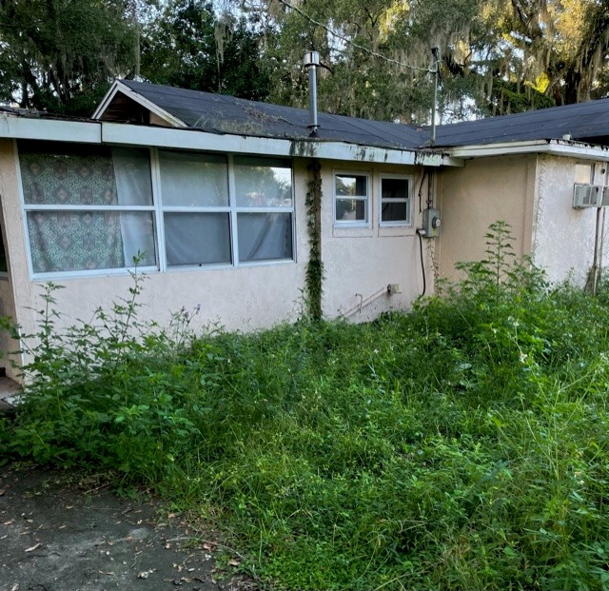

AGENDA ITEM 4: CV21-10 pam vamosi, 315 SE 5th street

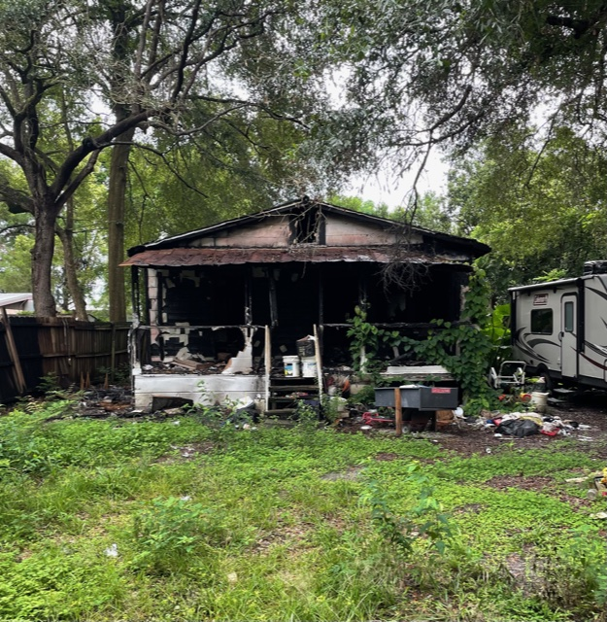

AGENDA ITEM 4: CV21-10 pam vamosi, 315 SE 5th street
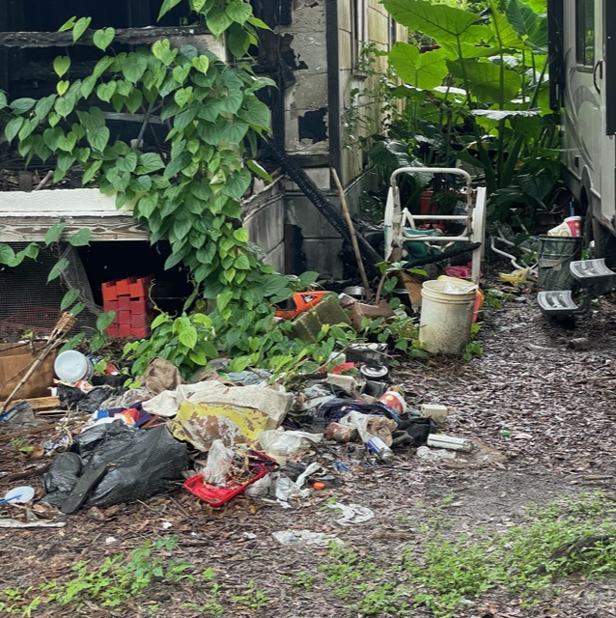

AGENDA ITEM 4: CV21-10 pam vamosi, 315 SE 5th street

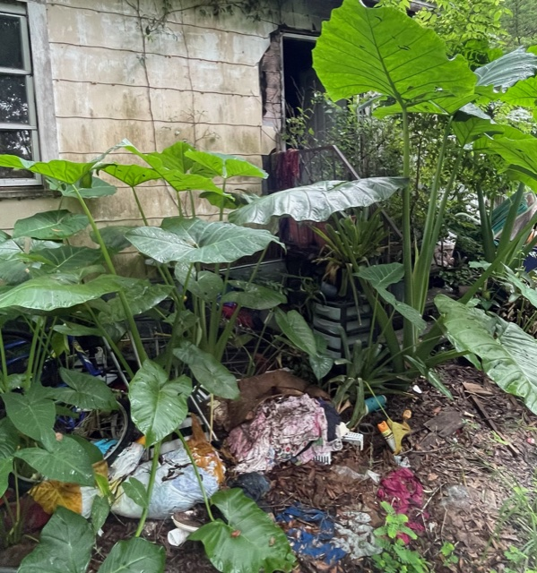

AGENDA ITEM 4: CV21-10 pam vamosi, 315 SE 5th street

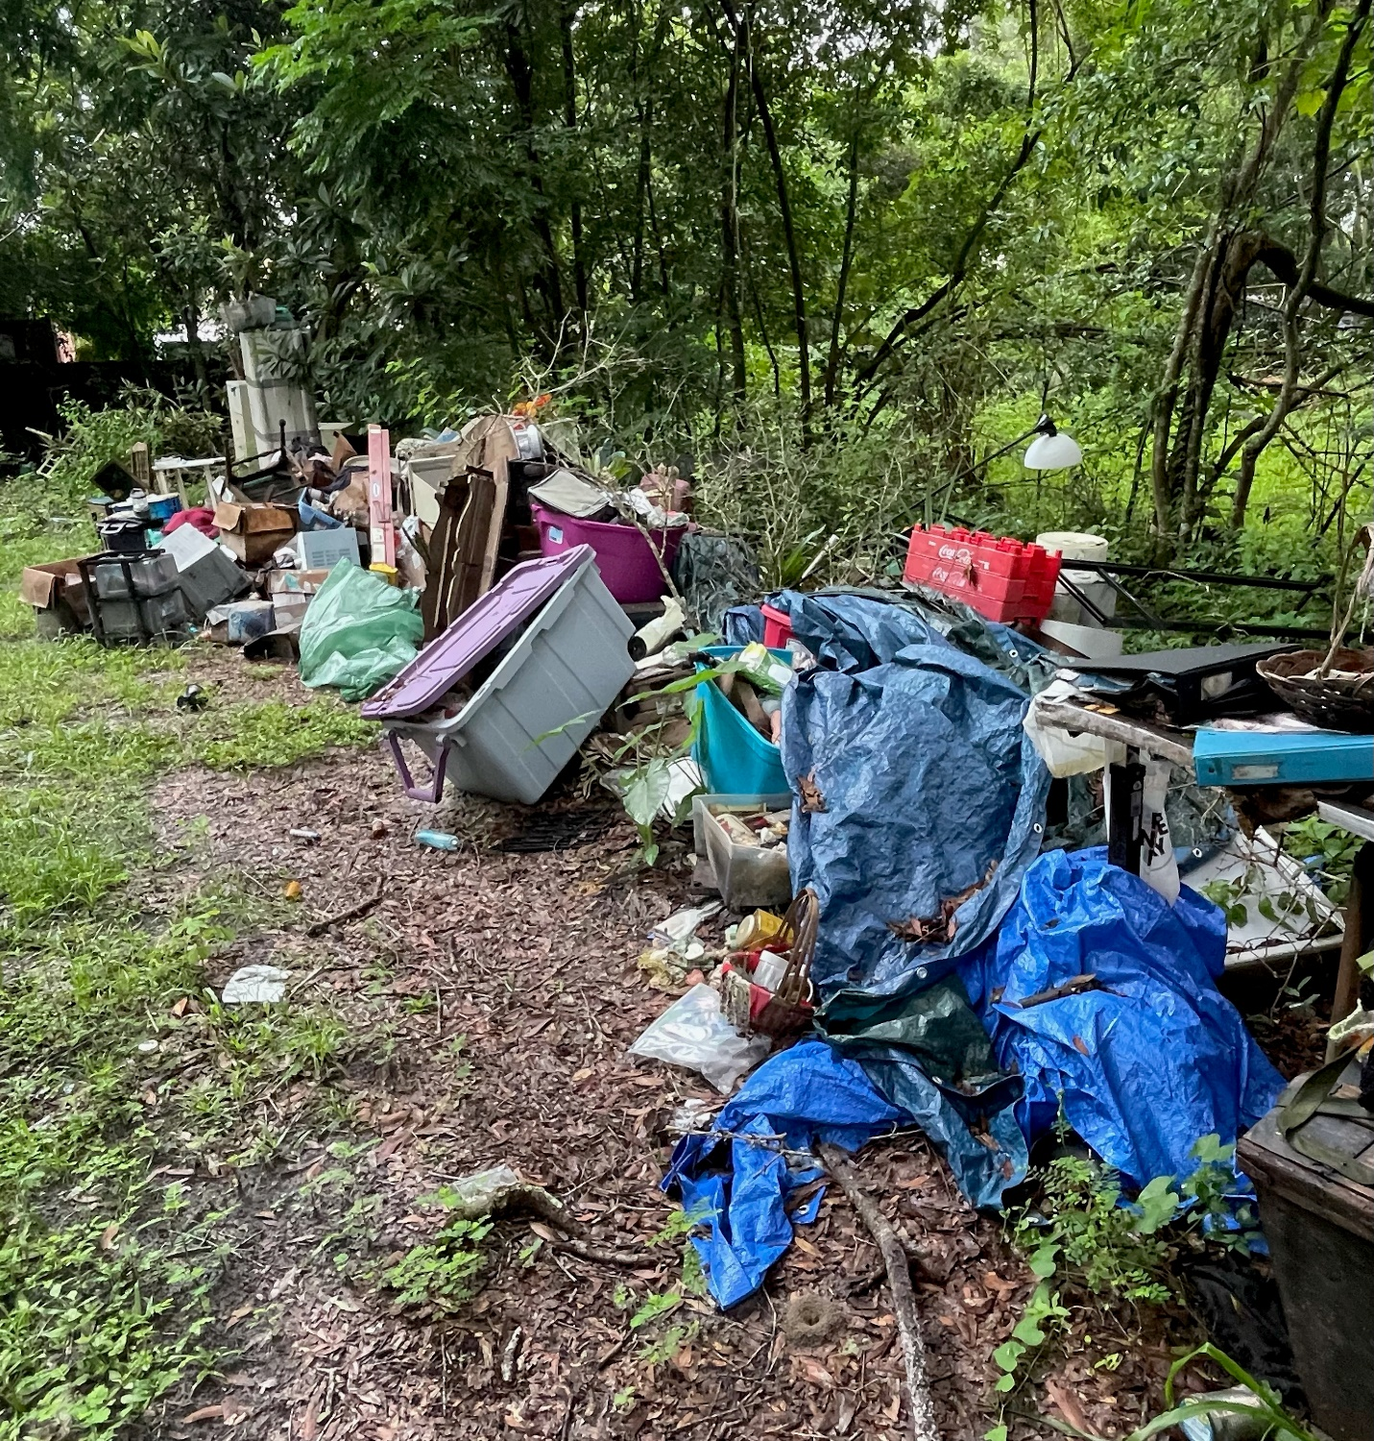

AGENDA ITEM 5: CV21-13 CSX Transportation, 715 E Noble Avenue

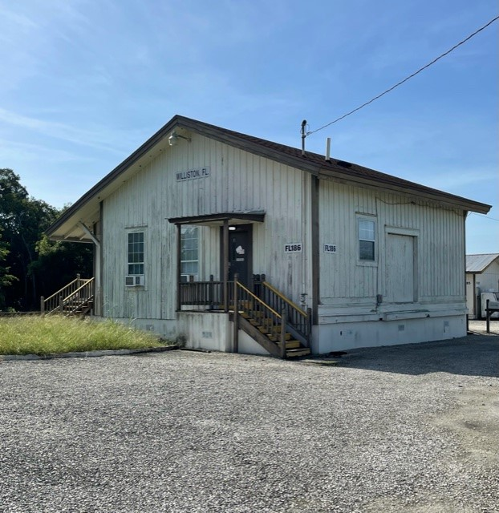

AGENDA ITEM 5: CV21-13 CSX TRANSPORTATION, 715 E NOBLE AVENUE
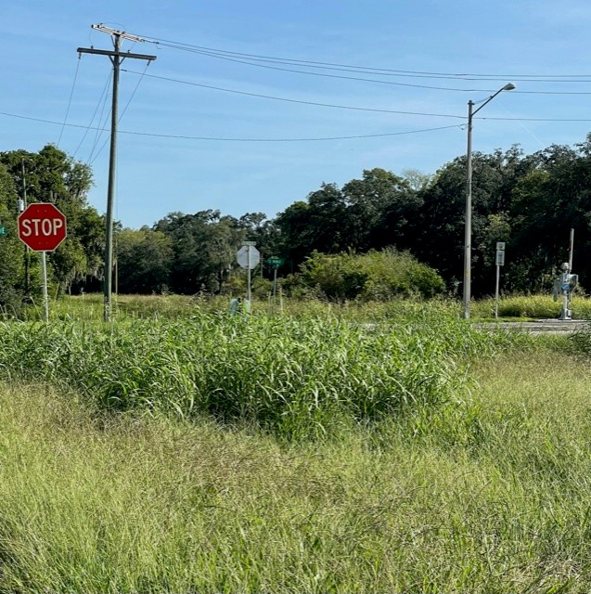

AGENDA ITEM 5: CV21-13 CSX TRANSPORTATION, 715 E NOBLE AVENUE
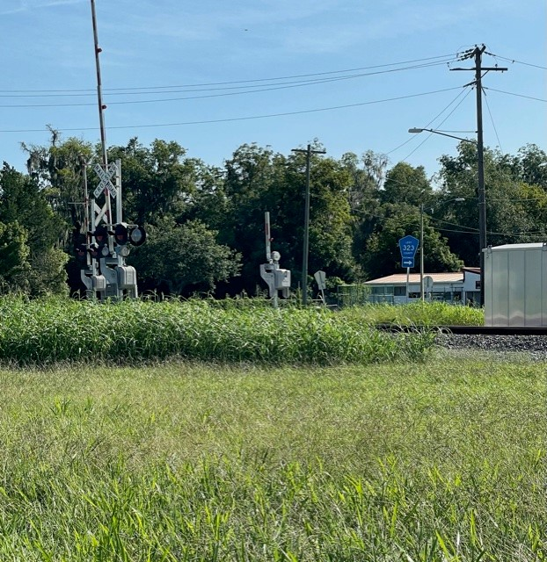

AGENDA ITEM 5: CV21-13 CSX TRANSPORTATION, 715 E NOBLE AVENUE
