CITY OF WILLISTON
BOARD OF ADJUSTMENT AND CODE ENFORCEMENT BOARD
AGENDA

DATE: August 23, 2021
TIME: 6:00 PM

PLACE: City Council Chambers

BOARD OF ADJUSTMENT AND CODE ENFORCEMENT COMMITTEE MEMBERS
Sharon Brannan, Chair | Staff
David Ragland, Vice Chair | Laura Jones, City Planner
Lisa Clark | Wayne Carson, Code Enforcement Officer
Colette Roth | City Attorney
Vacant | Krystal Ramos, Secretary of the Board
Paul Missall
Pam Myhree

Call To Order

Pledge

- Roll Call

- General Welcome Notice By Chairwoman

- Approval Of Agenda

- Approval Of Minutes – June 28, 2021 (SEE AGENDA ITEM 1)

- Remarks Of Staff Or Attorney

- Remarks Of Chairwoman

- City Staff Sworn By Secretary

CODE ENFORCEMENT

- NEW CASES:

      - cv21-04 Hardee’s (Buffer)
- Property Owner: Phase Three Brands (attn: Mark Robinson)
- Property Address: 306 W. Noble Avenue
- Non Compliance Notice from City: July 20, 2021
- Deadline for Compliance: TBD

An inspection by City Staff of the above listed parcel shows the property to have code deficiencies. Specifically, Section 60-43, City of Williston Code of Ordinances, which references the requirements for landscaped buffer areas. A notice was mailed on July 20, 2021 (SEE AGENDA ITEM 2).

No response has been received by City Staff from the Property Owner regarding their intentions for reinstalling the landscape buffer. The Property Owner’s neighbor states that there have been no changes to the missing buffer.

Staff recommends the following:

In BACE Case CV21-04, I move to find the Respondent (and/or additional responsible party) guilty of the violation(s) as set forth in the Notice of Violation and give the Respondent (and/or additional responsible party) ___ days to come into compliance by taking correction action.

- cv21-05 nature Coast Hospital (Former)
- Property Owner: Complete Business Solutions Group, Inc.
- Property Address: 125 SW 7th Street
- Non Compliance Notice from City: July 22, 2021
- Deadline for Compliance: August 21, 2021

An inspection by City Staff of the above listed parcel shows the property to have code deficiencies. Specifically, Section 48-2, City of Williston Code of Ordinances, which states that: “It shall be unlawful for any owner of real property within the city to create, keep, maintain, or allow the existence of any unsafe building or hazardous land, as defined in this chapter, in or on such property”. A notice was mailed on July 22, 2021 (SEE AGENDA ITEM 2).

No response has been received by City Staff from the Property Owner regarding their intentions for bringing the above listed property into compliance. A re-inspection performed by the Code Enforcement Officer shows no change to the property, however the Property Owner still has time to respond or comply as of the date of this agenda.

Staff recommends the following:

In BACE Case CV21-05, I move to find the Respondent (and/or additional responsible party) guilty of the violation(s) as set forth in the Notice of Violation and give the Respondent (and/or additional responsible party) ___ days to come into compliance by taking correction action.

- cv21-06 Lion’s Club (Repeat Offender)
- Property Owner: Williston Lions Club
- Property Address: 401 SE 6th Avenue
- Non Compliance Notice from City: July 20, 2021
- Deadline for Compliance: August 19, 2021

An inspection by City Staff of the above listed parcel shows the property to have code deficiencies. Specifically, Section 48-2, City of Williston Code of Ordinances, which states that: “It shall be unlawful for any owner of real property within the city to create, keep, maintain, or allow the existence of any unsafe building or hazardous land, as defined in this chapter, in or on such property”. A notice was mailed on July 20, 2021 (SEE AGENDA ITEM 4).

No response has been received by City Staff from the Property Owner regarding their intentions for bringing the above listed property into compliance. A re-inspection performed by the Code Enforcement Officer shows no change to the property, however the Property Owner still has time to respond or comply as of the date of this agenda.

- Cases Read For Closure By Secretary:

- Reduction Hearing:

- Old Business:

Case Status Review -

- CV21-02 Antique Store

- Property Owner: Michael Pesso
- Property Address: 716 W. Noble Ave.

Code Enforcement Officer noted that property owned by Mr. Michael Pesso, referred to as the Antique Store, located at 716 W. Noble Avenue was in violation of the City of Williston Code. To date, the property is still non-compliant and daily fines of $100 per day have not been paid the total to date is $4,700 (as of August 13, 2021). An official Order to Correct is to be filed by the City Attorney as soon as possible.

- New Business

BOARD OF ADJUSTMENT

- No New Business
- Announcements
- Adjourn

NEXT MEETING – SEPTEMBER 27, 2021

AGENDA ITEM 1:

CITY OF WILLISTON
BOARD OF ADJUSTMENT AND CODE ENFORCEMENT BOARD
MINUTES

DATE: June 28, 2021
TIME: 6:00 PM

PLACE: City Council Chambers

BOARD OF ADJUSTMENT AND CODE ENFORCEMENT COMMITTEE MEMBERS
Sharon Brannan, Chair | Staff
Lisa Clark | Laura Jones, City Planner
Colette Roth | Wayne Carson, Code Enforcement Officer
David Ragland | Frederick Koberlein, City Attorney
Paul Missall | Kryssy Ramos, Secretary of the Board
Pam Myhree

CODE ENFORCEMENT

- Call To Order- 6:00 PM

- Pledge

- Roll Call – Paul Missall, Excused Absence

- General Welcome Notice By Chairwoman

- Approval of Agenda – Ms. Colette Roth motioned to approve agenda. Ms. Pam Myhree seconded motion. Motion carried 5-0.

- Approval Of Minutes – January 25, 2021 and April 26, 2021 – Mr. David Ragland motioned to approve agenda. Ms. Colette Roth seconded motion. Motion carried 5-0.

- Remarks Of Staff Or Attorney - Mr. Fred Koberlein states that this will be his last meeting that he will be in attendance for, and states that he would hope would that the biggest point that the Board would retain from his time here is that it take two (2) hearings to enforce a lien. That pertains to more than 99% of Code Enforcement violations.

- Remarks Of Chairwoman - None

- City Staff Sworn By Secretary – Swore in City Planner Ms. Laura Jones, Code Enforcement Officer Mr. Wayne Carson.

CODE ENFORCEMENT

- Cases Read For Closure by Mrs. Laura Jones and Ms. Kryssy Ramos - The following properties have come into compliance:

- CV20-17 Green Shutters – In compliance as of the night of the last Board of Adjustments Code Enforcement Meeting. Nothing further.

- Repeat Non-Compliance Hearing:

  - CV21-02 Antique Store

- Property Owner: Michael Pesso
- Property Address: 541 W. Noble Ave.
- Non-Compliance Notice from City: February 24, 2021
- Deadline for Compliance: May 26, 2021
- Date Hearing Notice Mailed: June 8, 2021

Ms. Kryssy Ramos updates the Board, informing the Board that Mr. Pesso had not paid the Administrative Fine of $250 as of the time the agenda was written on June 18th, 2021 for the Board of Adjustment Code Enforcement meeting being held on June 28th, 2021; he did, however, pay the Administrative Fine late in the afternoon on June 18th, 2021. Mrs. Brannan asks for clarification as to whether or not this was the Administrative Fine, to which Ms. Ramos responded that it was. Mrs. Brannan states that we can now proceed with a per-day fine, and also asks if Mr. Pesso left any notice of his intentions at this point, to which Ms. Ramos responded “no”. Mr. Wayne Carson says, “he did not leave a thing.” Mrs. Brannan states that she assumes then that the property has not changed at all, and all he has done is pay the $250. Mr. Carson states that the only thing that has changed is that Mr. Pesso took down the cease-and-desist order and posted new “no trespassing” decals on his windows.

Mrs. Brannan catches up the Board on what the violations are and that the status of the building’s state of disrepair remains unchanged. Mrs. Brannan goes on to state that Mr. Pesso is not here to represent himself or his intent, and states that the building remains non-compliant and therefore the Board must decide on what action to take per the Staff recommendation. Mr. David Ragland states that it is his assumption that we should now begin imposing a daily fine, and he questions if the fine should start at $125 or $150. Mrs. Pam Myhree asks what we have done in the past [pertaining to a fine amount], and Mrs. Brannan replies that it can be any amount decided and agreed on by the Board, up to $250 a day. Mrs. Brannan continues that if the Board imposes a nominal fee, there would be no real impetus to comply, and she states that $250 a day seems a bit excessive, but even $50 a day adds up.

Mrs. Laura Jones asks for the floor and states that this is not just a vegetation issue, but a serious situation and elaborates on that statement. Mrs. Jones continues that this has been going on for a number of years and that Mr. Pesso only just paid his Administrative Fine, but he will not speak to anybody regarding his intentions in regards to bringing this property into compliance. Mrs. Brannan states that the Board can talk about it before deciding on how to proceed, and Mrs. Colette Roth suggests a $100 a day fine, with which Mrs. Myhree agrees. The Board discusses the option of a $100 a day fine, and Mrs. Lisa Clark responds “yes” when asked if she agrees with the recommendations.

It appears that all agree, and Mrs. Brannan asks for a formal recommendation.

In BACE Case CV21-02, I Pam Myrhee move to find the Respondent (and/or additional responsible party) guilty of the violation(s) as set forth in the Notice of Violation and impose a daily fine of $100 per day from June 28th, 2021 until property compliance by taking corrective action.

Mr. Ragland seconds the motion. Motion carries 5-0.

- Non-Compliant Case(s):

A. CV20-11 Hardee’s

a. Property Owner: Arc Café USA 001 LLC
b. Property Address: 306 W Noble Ave.
c. Non-Compliance Notice from City: April 14, 2021
d. Deadline for Compliance: May 14, 2021
e. Date Hearing Notice Mailed: June 11, 2021

Ms. Kryssy Ramos reads the violation letter for the Board. Mrs. Brannan asks Mr. Carson if he’s spoken with Hardee’s representative, to which Mr. Carson says that he has. Mr. Carson states that the District Manager, Mark Robinson, cleaned the property along with some of his staff and that the trash and debris has been “policed up and cleaned up”. Mr. Carson continues that Mr. Robinson will be making the necessary repairs to the fence and has also taken it upon himself to remove the picnic table from the premises as he thinks that there could be a link to the excessive trash and debris in relation to the availability of an area at which to sit and eat near where the trash is collecting. Mrs. Brannan asked when this was brought into compliance, and Mr. Carson states it had been a week or so ago, and that things should be better now that the District Manager is involved. Mrs. Brannan states that the problem is that this will most likely be an ongoing issue with an overflow of garbage, and if the fence is not contained all the way around, it will continue to flow into the neighbor’s yard.

Mr. Jobe Penney asks to speak and is sworn in by Ms. Ramos. Mr. Penney states that this is an ongoing process for about 8 years. Mr. Penney says that Mr. Carson spoke to Hardee’s during their remodel 2 years ago when they removed the buffering hedges and told Hardee’s staff that they had to replace the buffer as it was the law to have a buffer or a fence between commercial and residential. Mr. Penney states that Mr. Carson never forced the issue of replacing the buffer, and that he has headlights in his driveway, noise violations, and other reported issues (reported to Williston Police Department). Mr. Penney continues that he works hard to keep his property clean and that he is frustrated by not having a resolution after 6 years of complaints. Mrs. Brannan asks “So Wayne, what constitutes a buffer?”, to which Mr. Carson states that the buffer was not a part of the issue for tonight’s agenda.

Mr. Carson continues that he and Mrs. Jones went out to inspect the area in question in response to the complaint about the trash and the retention area fencing, and states that Mr. Robinson updated us with the current address for the business as older correspondence was not getting to the District Manager. Mr. Carson states that now that we have the current address, we are now able to get a hold of the District Manager more easily. Mrs. Brannan states that this has been ongoing for a while and that Mr. Penney has a valid complaint, so if Hardee’s needs to be cited for a fence [buffer] violation, then that needs to happen. Mr. Carson replies that he cannot force people to comply, and that what the Board of Adjustment Code Enforcement is here to discuss is the fence around the retention area and the trash; and that Hardee’s has a lawyer involved, so it will be up to the City lawyer, whoever that will be, and Hardee’s lawyer to come to a resolution at another time. Mrs. Brannan asks if the fence will be enough of a buffer to keep the trash from getting into Mr. Penney’s yard. Mr. Penney asks about the permitting status for the partial fence that Hardee’s installed a while ago with no permit, and Mr. Carson states that he cannot make them come in and apply for a permit, all he can do is talk to them and get things going in the direction of compliance. Mr. Carson continues that the only topic of discussion for this BACE meeting is the trash that took 3 employees and 11 trash bags to clean up.

More discussion ensues regarding the continued maintenance of the trash and debris, and Mrs. Brannan states that Hardee’s has not been compliant and remains non-compliant. Mr. Penney asks why the buffer is not being discussed being that there are codes that require a buffer between residential and commercial properties, and he states that the man who owns the gas station by his property, which is currently undergoing remodel, just installed a fence as a buffer. Mrs. Jones recounts a brief history of the events pertaining to this buffer situation, and states that when the bushes were removed it was because they were dead, and there is no fine for a buffer that died; she further explains the purpose of the buffer. Mrs. Brannan asks if they did have to install a buffer, and Mrs. Jones says that they did install the fence which buffers along the side of the residence. Mrs. Brannan states that the buffer is to serve two purposes: to keep the trash out of Mr. Penney’s yard, and to keep the lights out of his house from the drive through. Mrs. Jones replies that the buffer goes against the side of the property and then stops as Hardee’s felt that they were not required to go all the way down the side of the property. Mr. Penney states that when the property was remodeled, it should be considered “new”, and the buffer would need to be replaced. Mrs. Brannan asks if the fence went along the length of the property would that solve the issue, and Mrs. Jones replies that the City is unprepared to discuss the matter further at this time. Mrs. Brannan asks to get this issue on the next agenda so that BACE can be updated on the status of compliance.

Mrs. Jones states that she will ask the attorney to write something up about it. Mrs. Brannan asks if Hardee’s District Manager is going to apply for a permit, and then reviews the photos attached to the agenda, stating that it appears that there is nothing to keep trash from going into Mr. Penney’s yard. Mrs. Jones explains that that is not the purpose of a buffer, but rather to keep noise levels down and to buffer between a commercial and residential property. More discussion regarding the buffer and the approval two years prior to the current discussion, and Mrs. Jones states that the current buffer was previously approved, and that the City is not prepared to discuss it at this time.

Mrs. Brannan states that the Board can either give the restaurant another 30 days to comply, or the Board can just find him non-compliant and issue a fine. Mr. Fred Koberlein states that the agenda materials do not include the actual notice, and to clarify for the record that the fencing consists of two issues: the fencing around the retention area, and the fence that is considered a “buffer”, and he asks if that is what went out to the property owner in the notice, to which Mrs. Jones answers that the letter in the agenda is what went out to the property owner. Mr. Koberlein continues that the Board can consider all 3 issues since they are in the notice. Mrs. Brannan states that they can decide on giving him [Hardee’s District Manager] 30 days, and Mrs. Jones states that the Board can give 15 or even 10 days, and Mrs. Roth suggests 10 days. Mr. Ragland suggests 10 days with a $250 fine.

Mr. Koberlein reads back his previous response regarding the buffer issue in his response to the lawyer representing Hardee’s, and states that Hardee’s has not sent anybody to speak in their defense which is a right that they have. Mrs. Lisa Clark asks for clarification, and Mr. Koberlein states that if the City Administration has cited code violations, Hardee’s has the right to send representation in their defense, but they have chosen not to attend a hearing to defend themselves. Mrs. Brannan says that they need to buffer, and Mr. Carson states that the City cannot require Hardee’s to erect a fence, and Mrs. Jones states that being that Hardee’s is in the CRA district, the City does have some pull in regard to the design requirements being adhered to so as to not install anything inadequate or unsightly. The question is asked if Mr. Carson needs to cite Hardee’s again, or if this issue just needs to be added to the next agenda; Mr. Carson states that Mr. Robinson will be in town and that he can ask what his plans are to come into compliance.

Mr. Koberlein speaks again, stating that Mr. Carson is correct, we cannot require Hardee’s to install a fence specifically, but they are required to install a landscape buffer. The fence around the retention area does need to be permitted, but the City cannot require a fence as a buffer between the two properties. More discussion to clarify what can and cannot be required regarding the retention fence and the buffer. Mr. Penney states that he has been working with the City Manager, Mrs. Jackie Gorman, for some time, and that Hardee’s representatives had be previously notified by Mrs. Gorman to replace the buffer, all via certified letters. Mr. Koberlein replies, stating that it does not matter how Hardee’s was notified, it only matters that the response is according to code, citing a reference to Section 60-381 of the City of Williston Municipal Code which outlines minimum landscaped buffering; further explaining that there only needs to be a buffer when a structure is erected or expanded, and states that the landscaped buffering should be addressed in response to the citizen’s argument; however, this is not the issue to be addressed at this meeting, as Mr. Carson had previously stated.

Mrs. Brannan asks Mr. Carson to let Mr. Robinson know that he is still non-compliant for the buffer, and MR. Carson agrees that he will inform Mr. Robinson. Mrs. Brannan goes on to address the two issues that are before the Board, which is the fencing around the retention area, and states that the trash is compliant, so the Board will move on to recommendations and will need to decide on whether or not to assess an Administrative Fee. Mrs. Myhree states that 15 days should be plenty to comply and makes a motion to give the Respondent 15 days to come into compliance, and also moves to assess a $250 Administrative Fee to be paid in no more than thirty (30) days.

In BACE Case CV20-11, I move to find the Respondent (and/or additional responsible party) guilty of the violation(s) as set forth in the Notice of Violation and give the Respondent (and/or additional responsible party) _15_ days to come into compliance by taking correction action.

AND

I move to find the Respondent responsible for, and assess, reasonable costs and Administrative Fees in the amount of ($_250__) due to be paid by no less than 30 days.

Mr. Ragland seconds the motion. Motion carries 5-0.

Mrs. Myhree asks if there is a law regarding that amount of trash on the property, to which Mrs. Jones replies it is a D.E.P. issue and could have result in fines from that entity. More discussion occurs regarding the aforementioned issues, and Mrs. Brannan states that hopefully it will be taken care of this time since they are already working on the issues they were cited for.

- Reduction Hearing – None

- Old Business – None

- New Business

  - Election of Vice Chair

Mrs. Brannan asks if the seat for Vice Chair has been published yet, to which Mrs. Jones replies that it has. After some discussion, Mrs. Brannan nominates Mr. Ragland as Vice Chair, and Mrs. Myhree seconds the motion. Motion carries 5-0. Mr. David Ragland is appointed as Vice Chair of the Board of Adjustment Code Enforcement.
BOARD OF ADJUSTMENTS

- No New Business (Called to order at 6:52 PM)

- Announcements - None

- Adjourn – Mrs. Brannan adjourns at 6:53 PM.

NEXT MEETING – JULY 26, 2021

_____________________________ ______________________________
SHARON Brannan, Chairperson KRYSSY RAMOS, Secretary

AGENDA ITEM 2:

On June 28, 2021 a public hearing was held and it was brought to The Board of Adjustments and Code Enforcement that the property at 306 W. Noble Avenue had a buffer between the restaurant property and the neighboring residence. Upon further investigation, a hedge buffer was installed and was a part of the original design when the restaurant was initially erected. According to the City of Williston Municipal Code Sec. 60-43, Landscaped buffer areas, there is a requirement to maintain the buffer for the lifetime of the establishment, even if it should change hands in the future.

Due to the fact that the intensity of the uses of the structures varies greatly with Hardee’s being high-intensity and the neighboring property being low-intensity, the importance of maintaining the buffer is significant and required. At this time, we are requesting the replacement of the buffer as it pertains to the City of Williston Municipal Code, which must keep in compliance with the Central Business District design requirements as well. Please bear in mind that the practice of maintaining the buffer is not only required, but a best practice for preserving neighborliness in your community.

Sec. 60-43. - Landscaped buffer areas.
The use of properly planted and maintained buffer areas may reduce and ease potential incompatibility between or among different uses of land in proximity to each other.
(1) Requirements. Where these land development regulations require a landscaped buffer area, the following requirements shall be met:
a. The landscaped buffer area width shall be measured at right angles to property lines and shall be established along the entire length of and contiguous to the designated property line or lines. All buffered areas shall be maintained between two and six feet above average ground level and no more than six feet wide.
b. The area shall be so designed, planted, and maintained as to be 80 percent or more opaque when viewed horizontally; provided, however, that plantings located in the required front yard shall not exceed two and one-half feet in height.
c. Types and numbers of plantings for landscaped buffers shall be submitted with application for building permit. No building permit shall be issued without such data, where these land development regulations require a landscaped buffer area or areas.
d. Plantings shall be of a size and type which will ensure the meeting of the 80 percent opacity requirement within no longer than 30 months of the date of first planting. Where questions may arise as to the suitability of proposed plant materials to meet this requirement, final determination of suitability shall be made by the land development regulations administrator.
e. The remainder of the required landscaped buffer area not covered by planting shall be landscaped with grass, ground cover, or other landscape treatment; except as otherwise provided herein, structures including buildings and off-street parking and loading areas shall not be located in any required landscaped buffer area.
f. The landscaped buffer area shall be maintained by the property owner and successors and continued so long as the main use continues. Failure to maintain the landscaped buffer area as set out above shall be a violation of these land development regulations.

Please contact Wayne Carson, Code Enforcement Officer at your earliest convenience to discuss this matter. The contact number is 352-558-4219.

NON-COMPLIANCE PHOTOS: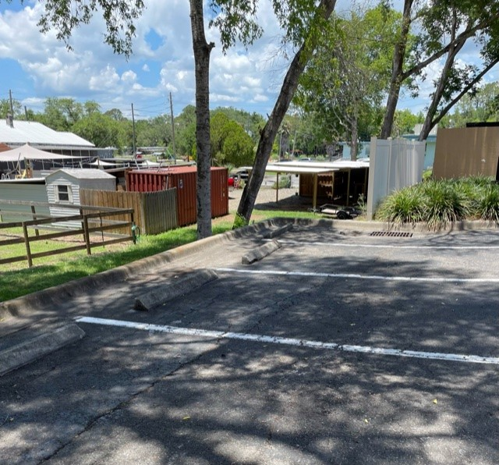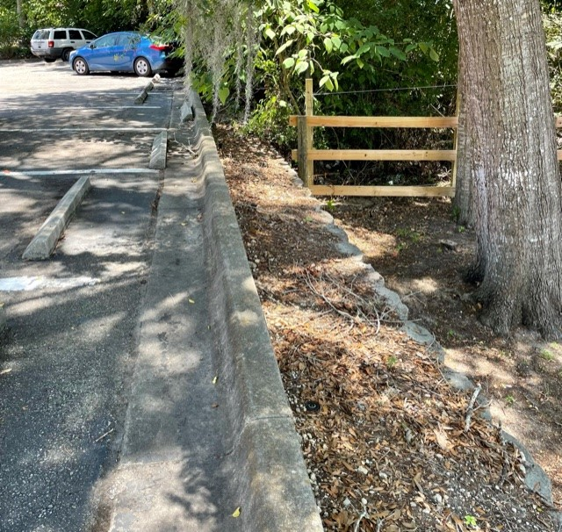

AGENDA ITEM 3:

An inspection by City Staff on June 11th, 2021 and July 22nd, 2021 of the above listed parcel shows the property to have code deficiencies. Specifically, Section 48-2, City of Williston Code of Ordinances, which states that: “It shall be unlawful for any owner of real property within the city to create, keep, maintain, or allow the existence of any unsafe building or hazardous land, as defined in this chapter, in or on such property”.

To avoid Code Enforcement action the structure will need to be repaired or the property be brought into compliance with the Code of Ordinances.

Please ensure compliance by August 21st, 2021 at which time the property will be re-inspected. Failure to bring the property into compliance with City of Williston Code will result in referral of the case to the Board of Adjustment and Code Enforcement, which has the power to issue fines and/or place liens on the property.

Please contact Wayne Carson, Code Enforcement Officer at your earliest convenience to discuss this matter. The contact number is 352-558-4219.

NON-COMPLIANCE PHOTOS:
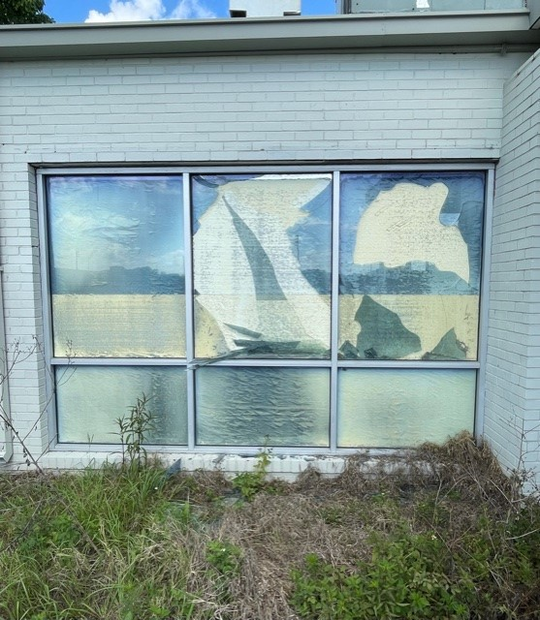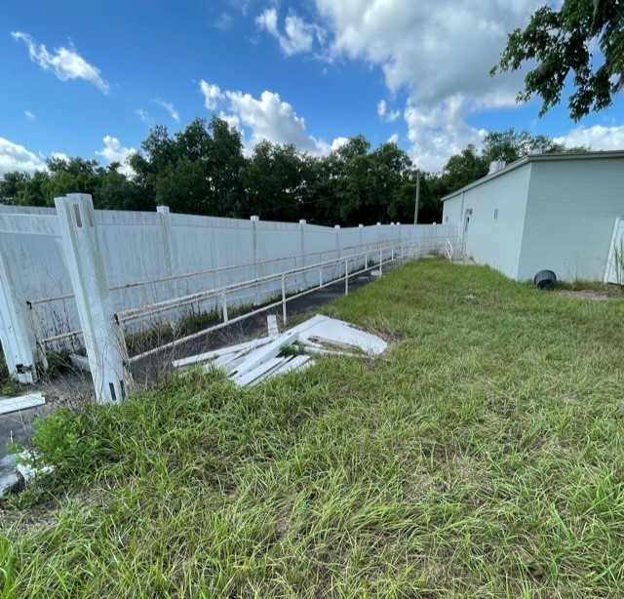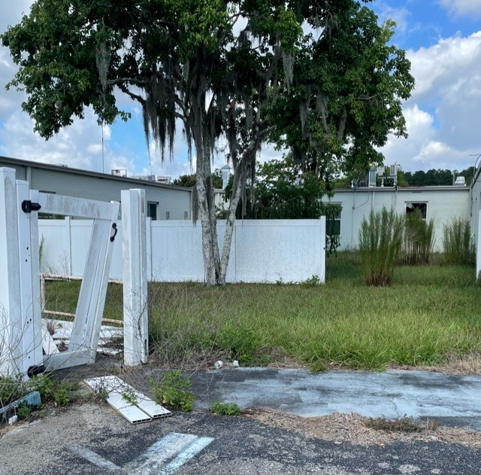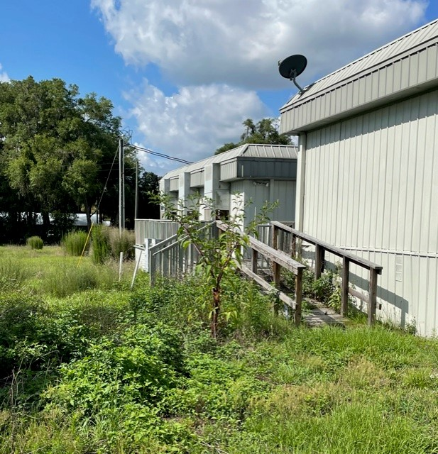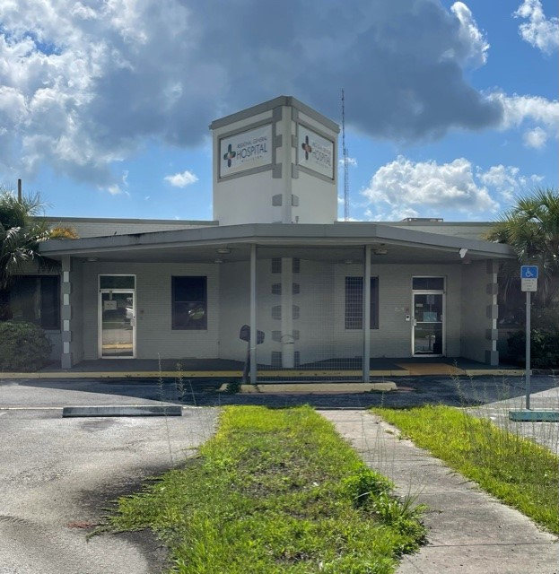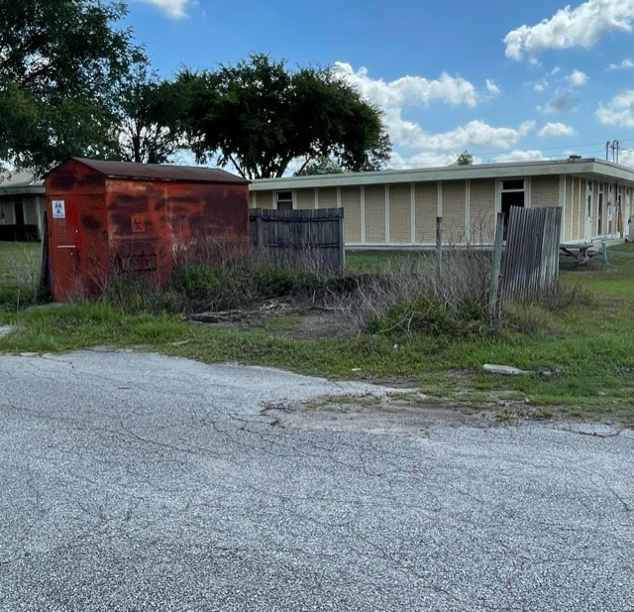

AGENDA ITEM 4:

An inspection by City Staff on July 20, 2021 of the above listed parcel shows the property to have code deficiencies. Specifically, Section 48-2, City of Williston Code of Ordinances, which states that: “It shall be unlawful for any owner of real property within the city to create, keep, maintain, or allow the existence of any unsafe building or hazardous land, as defined in this chapter, in or on such property”.

To avoid Code Enforcement action the structure will need to be repaired or the property be brought into compliance with the Code of Ordinances.

Please ensure compliance by August 19, 2021 at which time the property will be re-inspected. Failure to bring the property into compliance with City of Williston Code will result in referral of the case to the Board of Adjustment and Code Enforcement, which has the power to issue fines and/or place liens on the property.

Please contact Wayne Carson, Code Enforcement Officer at your earliest convenience to discuss this matter. The contact number is 352-558-4219.

